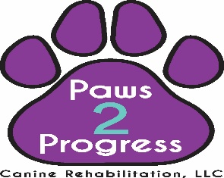
_______________
¹⁽⁵⁴⁰⁾³⁹²⁻²⁰⁹⁸
^{pawstoprogressrehab@gmail.com}
VETERINARIAN REFERRAL FORM

Veterinary Clinic _____________________________ Phone number __________________
Client _____________________________________ Pet _________________________
We ask that you please include all pertinent medical information including medication profile, pre-existing conditions, diagnostic tests, or any additional information relevant to the care of this patient.
Diagnosis/Surgeries:
_____________________________________________________________________________
_____________________________________________________________________________
Precautions/Contraindications:
______________________________________________________________________________
______________________________________________________________________________
Current medications:
______________________________________________________________________________
______________________________________________________________________________
Any other pertinent information you would like to disclose:
______________________________________________________________________________
______________________________________________________________________________

_____________________________________ ________________
DVM signature Date
*Please email once completed
Per section 18VAC150-20-172 of the Veterinary Practice Act in VA: Massage therapy, physical therapy, or laser therapy may be delegated by a veterinarian to persons qualified by training and experience by an order from the veterinarian. 18VAC150-20-172.

